Computer systems
CFGS DAW

Computer Systems
UD 10. Linux - Part 2

Alfredo Oltra
alfredo.oltra@ceedcv.es
2022/2023
Versión:220729.2104

Licencia


Reconocimiento – NoComercial – CompartirIgual (by-nc-sa): No se permite un uso comercial de la obra original ni de las posibles obras derivadas, la distribución de las cuales se debe hacer con una licencia igual a la que regula la obra original.

Nomenclatura

A lo largo de este tema se utilizarán distintos símbolos para distinguir elementos importantes dentro del contenido. Estos símbolos son:

◻ Importante

 Atención

 Interesante

INDEX
1. Users in Linux 4
1.1 Files “/etc/passwd” and “/etc/shadow” 4
1.2 Command “sudo” and sudoers list 5
1.3 Command “su” 5
1.4 Creating users in Linux 6
2. Groups in Linux 6
2.1 File “/etc/group” 6
2.2 Creating groups in Linux 6
3. Files and directories in Linux 7
3.1 Types of files 7
3.2 Hidden files 7
4. Permissions in Linux 7
4.1 Permission grant algorithm 8
4.2 Using chmod command to set permissions 9
4.3 Special permissions 9
5. Main commands 10
6. Additional material 12
7. Bibliography 12

UD010. Linux - Part 2

Users in Linux
Linux is a multi-user operating system.
Users in Linux have a name associated to them, but internally they are identified by a number. This identifier is called UID. If two users have different name but same UID, they are internally the same user. More information in https://en.wikipedia.org/wiki/User_identifier
Basically there are two kind of users: normal users and root.
- A normal user is a user with UID greater than 0 and can do limited operations and only access/modify to resources that he has permission to access.
- Root user is a user with UID=0. It is the main administrator of the system and virtually can do almost everything (change configuration, install programs, install drivers, run servers, read/delete any file,…).
 To do operations being root user is very dangerous (you can do a mistake and broke your system). If you enter in a system being root, you have to know very well what are you doing.

Files “/etc/passwd” and “/etc/shadow”
List of users is stored in a file called “/etc/passwd”. It stores several attributes like UID, home directory, if user is enabled or not,…
If we execute “cat /etc/passwd” we can view its content.
More information about “/etc/passwd” file can be found in
https://www.cyberciti.biz/faq/understanding-etcpasswd-file-format/
Also encrypted password can be stored in “/etc/passwd”, but it is not recommended for security reasons (“/etc/passwd” could be read by everybody).
For this reason, there is other file for store passwords called “/etc/shadow” that only root user can read and modify.
More information about “/etc/shadow” file can be found in
https://www.cyberciti.biz/faq/understanding-etcshadow-file/
 Summarizing, “/etc/passwd” stores general info of users and “/etc/shadow” stores encrypted passwords.

Command “sudo” and sudoers list
A few lines ago we have said that there are 2 kind of users: root and normal users. It is an inefficient and insecure way to manage admin accounts.
For this reason modern Linux distributions like Ubuntu or Mint:
- By default, root account is deactivated (you can’t log in as root).
- There is a list called “sudoers”. In this list, you can give several privileges to normal users.
- Most common (and useful) privilege is to “became root” temporally using a command called “sudo” before the instruction to perform.
With this tool and this configuration, system can have more than one admin (each users that is in sudoers list can perform root operations).
Also it is mandatory to use the command “sudo” before the command run as root. It increase security because it is supposed that if you use “sudo” you know what are you doing.
Example:
If user pepe (UID=1001) is in sudoer list and executes
“sudo cat fichero.txt”
It executes the command “cat fichero.txt” being root (UID=0).
 When you run first time in your session a sudo command (or your last sudo command was a lot of time ago), the system ask you your own login for security reason.
More information in https://en.wikipedia.org/wiki/Sudo

Command “su”
Command “su” is an abbreviation of “Switch User”.
This command can be called:
- Without parameters: in this case, it tries to log as root (UID=0). It works even if root account is disabled.
- With parameter: it has a parameter that is the username that you want to log in.
If you run the command being root, it automatically logs as the user. If you are a normal user, it ask you the user password.
Example:
“su pepe”
The system will try to log in as the user “pepe”.
“sudo su”
The system will try yo log as root (UID=0).
More information in https://en.wikipedia.org/wiki/Su_(Unix)

Creating users in Linux
In this page, you can read information of how to create users (by command line) and if you wish, give them “sudo” privileges: https://www.digitalocean.com/community/tutorials/how-to-add-and-delete-users-on-ubuntu-16-04
Also you can watch an example with graphical interface in this video
https://www.youtube.com/watch?v=DQHS1tQ2Xt8
 When you create an user in Linux, default content of its new home directory is obtained from directory “/etc/skel”. It works like a “template”. More information in http://linuxg.net/the-unix-and-linux-skeleton-directory-etcskel/

Groups in Linux
Linux let you to create groups of users. It is useful to give permissions or privileges (like sudoers list) to a complete group (For example, you can give “sudo” privilege to a group and each member of this group could run sudo command to became root).
A user can be member of several groups at time.
Like users, groups have a name, but internally they are identified by an integer GID. If two groups share the same GID, internally they are the same group.

File “/etc/group”
There is a file “/etc/group” where groups are listed. Each line is a group and it stores several information like name, GID and the most important value: the complete list of users that are members of that group.
More information about “/etc/group” in
https://www.cyberciti.biz/faq/understanding-etcgroup-file/

Creating groups in Linux
In this link you can watch how to create a group and add an existing username to that group using console http://www.omnisecu.com/gnu-linux/redhat-certified-engineer-rhce/how-to-create-a-new-group-in-linux-using-groupadd-command.php
Also you can view how to do it graphically in this video https://www.youtube.com/watch?v=ZNeWntArcOg

Files and directories in Linux

Types of files
In Linux there are those types of files:
- Regular files: contains information. They are regular files, like we use everyday.
- Directories: they are special files with references to other directories and files.
- Links
  - Symbolic links: it is a file that contains the route to other file. Is similar to Windows shortcuts. If you delete original file, symbolic link remains, but it points to a nonexistent file.
  - Hard links: it is not a type of file, it is a second name to a file. If you create a hard link of a file, for the file system they are the same file and there is no way to know which is the original. If a file have more than one reference, it is only delete when all references al deleted.
- Special files: they are files that usually represent physical devices, like storage units, printers….

Hidden files
In Linux, hidden files are files that start with “.” like “.bash”. When you list a directory, they don’t appear, unless you use “-a” parameter. You can see them using “ls -a”.

Permissions in Linux
In Linux using command line command “ls -l” you can view detailed information about files and directories. This information contains permissions of each file or directory.

The main types of permissions in Linux are:
- Read
  - In a file: lets to read its content.
  - In a directory: lets to list its files, directories names and attributes (command ls).
- Write
  - In a file: you can modify content of the file.
  - In a directory: you can delete or create files and directories in that directory.
- Execute
  - In a file: you can run the file (like Windows “.exe”).
  - In a directory: you can enter the directory (cd command).
This main permissions should be defined in 3 groups: owner (affects to owner of the file), group (affects to member of the group) and others (affect to other users).

An example of “ls -l” command applied to permissions:
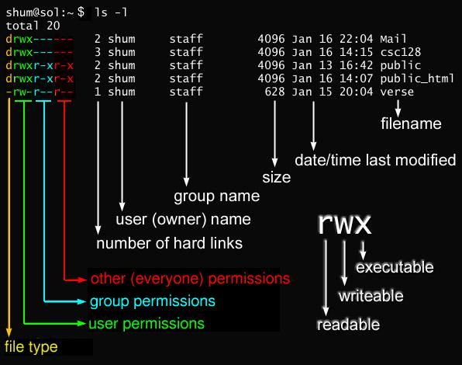

Permission grant algorithm
To determine if a permission is granted or not, it follows the next algorithm:

- First check if user is root (UID=0). If it is true, permission is granted.
- Secondly check if user is the owner. If it is the owner, “owner permissions” are applied.
- Thirdly if user is not root or the owner, but it is a member of group associated to the file, “group permissions” are applied.
- Lastly, it user is not root, not the owner and not member of group, “other permissions” are applied.
 It is possible to find contradictions like “others” have more permissions than “owner”. If “others” can write and owner can’t, although it is strange, it is a valid configuration.

Using chmod command to set permissions
Command chmod is used to set permissions. Only root and owner of the resource can change permissions.
Chmod mainly has two notations:
- Alpha notation:
  - Example: chmod u=rwx, g=rx, o=- myFile.txt #It puts all permissions to owner, read an execution to group and nothing to others.
- Octal notation:
  - Uses “Binary value” of an octal value to set permissions. For example, 5 is 101 in binary and it is equivalent in rwx to read and execute permissions.
  - Example: chmod 750 myFile.txt It puts the same permissions that last example
More information about it in http://www.perlfect.com/articles/chmod.shtml

Special permissions
We have talked about 9 bits of permissions (rwx for owner, rwx for groups and rwx for other). But there are 3 bits more: setUID, setGID and Sticky bit:
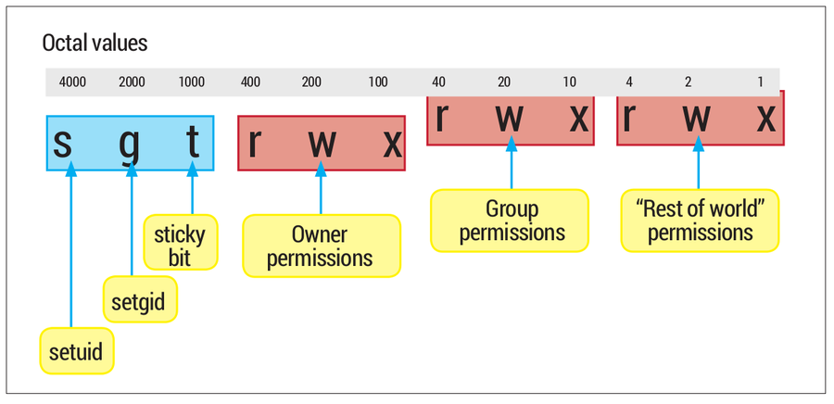
- setUID: https://en.wikipedia.org/wiki/Setuid
  - In files: if setUID permission is activated, when you execute that file, you don’t execute it with your own UID, you execute it with owner UID.
  - In directories: if setUID permission is activated, if you create a file or a directory, the owner isn’t you, is the owner of the parent directory where you are.
- setGID: https://en.wikipedia.org/wiki/Setuid
  - The same than setUID, but with group ID instead user ID.
- Sticky bit: https://en.wikipedia.org/wiki/Sticky_bit
  - Nowadays is mainly used in directories. If somebody have write permission in a directory, he can creates files and directories but he also can delete any file or directory. If sticky bit is activated in a directory, any person with write permissions can create files and directories, but only can delete files and directories that are owned by him.
    - The only exception are root and owner of the parent directory.
More information about those permissions in http://www.unixrock.com/2013/09/how-to-use-setuid-setgid-and-stickybit.html

Main commands
In this section we are going to describe the main console commands on Linux systems. If you want to obtain detailed information about each of them, you can use “man command”.

Command | What it does | Example
Commands to manage the interface
man | Shows help of a command | man ls
clear | Clear screen | Clear
echo | Show a literal text in screen. | echo “Hello World”
exit | Closes the session in console | exit

Command | What it does | Example
Commands to configure the system
date | Set date of the system | date #Shows date  date -s #Sets date
cal | Shows the calendar | cal
shutdown | Shutdown the system | shutdown
reboot | Reboot the system | reboot

Command | What it does | Example
Commands to obtain information about disks
du | Shows disk usage for each file. | du -h  #Human readable format
df | Shows information about filesystems | df -h  #Human readable format

Command | What it does | Example
Commands to manage files and directories
touch | Creates an empty file | touch myfile.txt
vi / nano | Creates/edits a text file | nano myfile.txt  vi myfile.txt
mkdir | Creates a directory | make mydir
cat  more | Shows the content of a text file | cat myfile.txt  more myfile.txt
grep | Searches a text patron in a text file | grep root /etc/password
ls | Shows contents of a directory | ls  ls -la
cd | Changes directory | cd /home #Absolute route  cd ../myDir #Relative route
pwd | Shows current route | pwd
rm | “rm” deletes files  “rm -r” deletes a directory recursively | rm myfile  rm -r myDirectory
cp | “cp” copy a file  “cp -r” copies a directory recursively | cp myFile /home/admin  cp -r myDir /home/admin
mv | Moves/renames a file or a directory | mv myFileOldName /home/myNewName
ln | “ln” creates a hard link.  “ln -s” creates a symbolic link (like windows shortcuts. | ln myFile hardLinkMyFile  ln -s myFile shortcutMyFile
mount | Mount a device in a folder. | mount /dev/sda1 /media/myDisk

Command | What it does | Example
Commands related to permissions
chmod | Changes permissions of a file or a directoy | chmod 750 myFile
chown | Changes propietary/group of a file or a directory | chown newuser:newgroupt my file

Additional material
[1] Glossary.
[2] Exercises

Bibliography
[1] “The Linux command line” Creative Commons book http://linuxcommand.org/tlcl.php

